Tab 1



Mtel (Thailand) Co., Ltd.

For

T.C.C. Technology Co., Ltd.

One Bangkok Mobile Application
Invitation Code & Upgrade Membership
User Manual Document
To
T.C.C. Technology Co., Ltd.

Total 25 sheets (w/h cover sheet)
 | PROJECT NAME | JOB NO. | DOCUMENT NO. | REV.
 | One Bangkok Mobile Application - Invitation Code & Upgrade Membership User Manual Document |  |  | 01

Content table
1. Document Purpose 3
2. Feature Overview 4
3. Invitation Code 4
3.1. Purpose 4
3.2. User Journey – Registration with Invitation Code 4
Step 1 – Select Login with Invitation Code 4
Step 2 – Enter Invitation Code 5
Step 3 – Accept Terms & Conditions 5
Step 4 – Complete Account Setup 6
Step 5 – Account Creation 7
3.3. Business Rules – Invitation Code 7
3.4. Profile Restrictions for Invited Users 8
3.5. Error Handling – Invitation Code 8
4. Upgrade Membership 10
4.1. Purpose 10
4.2. User Journey – Upgrade Membership 10
Step 1 – Navigate to My Profile 10
Step 2 – Enter Code 11
Step 3 – Tier Upgrade 11
4.3. Business Rules – Upgrade Membership 12
4.4. Error Handling – Invitation Code 12
5. Code Generation (Retail BU Process) 13

One Bangkok Mobile Application - Invitation Code and Upgrade Membership
To
T.C.C. Technology Co., Ltd.
This document serves as the official User Manual for the Invitation Code and Upgrade Membership features within the One Bangkok Application. The purpose of this manual is to provide clear guidance on how these features operate within the application following their migration from the previous BZB web-based implementation to a fully native in-app experience integrated with the Single Sign-On (SSO) platform.
With SSO acting as the primary source of truth, invitation and upgrade membership codes are now generated, stored, and validated within a centralized system to ensure accurate identity management and tier assignment. This enhancement improves operational efficiency, data consistency, and overall user experience.
This manual outlines feature objectives, user workflows, business rules, system behaviors, and operational processes to support Business Units, Customer Support, and relevant stakeholders at T.C.C. Technology Co., Ltd. in effectively utilizing and managing these features.

Document Purpose
This User Manual provides operational guidance for the Invitation Code and Upgrade Membership features within the One Bangkok Application.
The document explains:
- Feature overview and objectives
- User interaction steps
- Code generation process
- Business rules and validation logic
- Expected system behaviors
- Error handling scenarios
This manual is intended for:
- Retail Business Unit (BU)
- Customer Support Team
- Operations Team
- Internal stakeholders
It complements the approved Statement of Work (SOW) and Technical Design Document (TDD).

Feature Overview
The Invitation Code and Upgrade Membership features allow controlled access and tier management within the One Bangkok Application.
Both features are integrated with the Single Sign-On (SSO) platform, which acts as the system of record for:
- Code storage
- Code validation
- Tier assignment
- Identity synchronization
There are two primary use cases:
- Invitation Code – For new user registration
- Upgrade Membership – For existing users to upgrade retail tier

Invitation Code

Purpose
Invitation Code allows selected users (e.g., VIPs) to:
- Register using a pre-generated code
- Receive a predefined retail tier
- Access application features based on assigned privileges

User Journey – Registration with Invitation Code

Step 1 – Select Login with Invitation Code: User selects “Login with Invitation Code” on login screen.
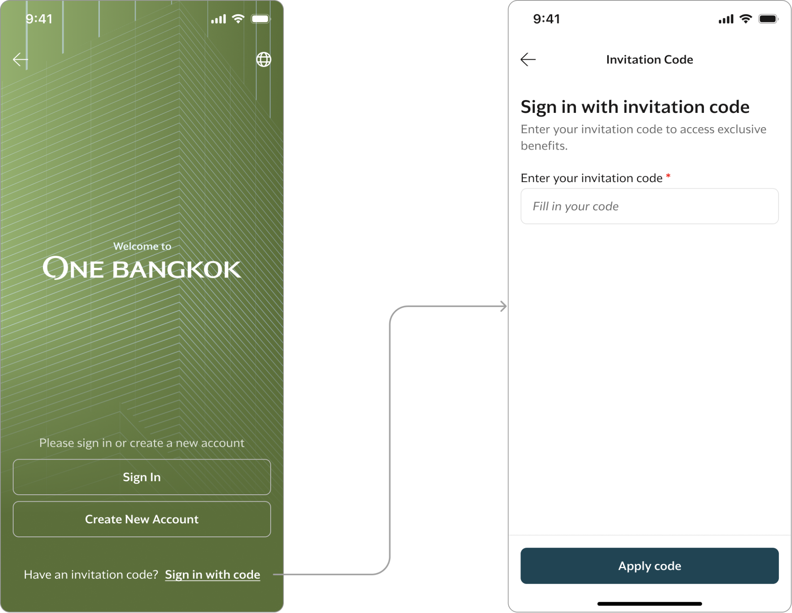

Step 2 – Enter Invitation Code: User enters a 10-character code.
System rules:
- Uppercase letters (A–Z)
- Numbers (0–9)
- Maximum length = 10 characters
- Auto-uppercase conversion
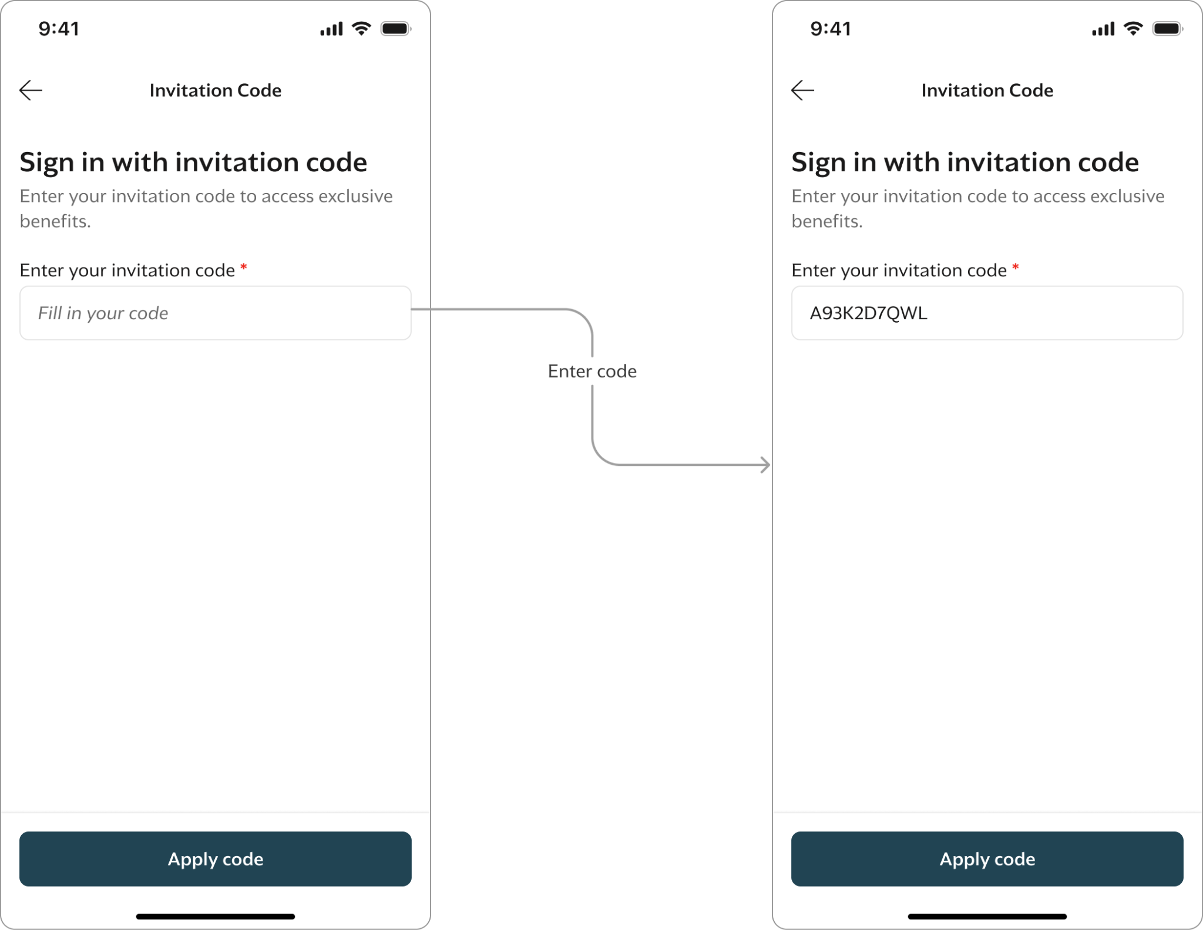

Step 3 – Accept Terms & Conditions
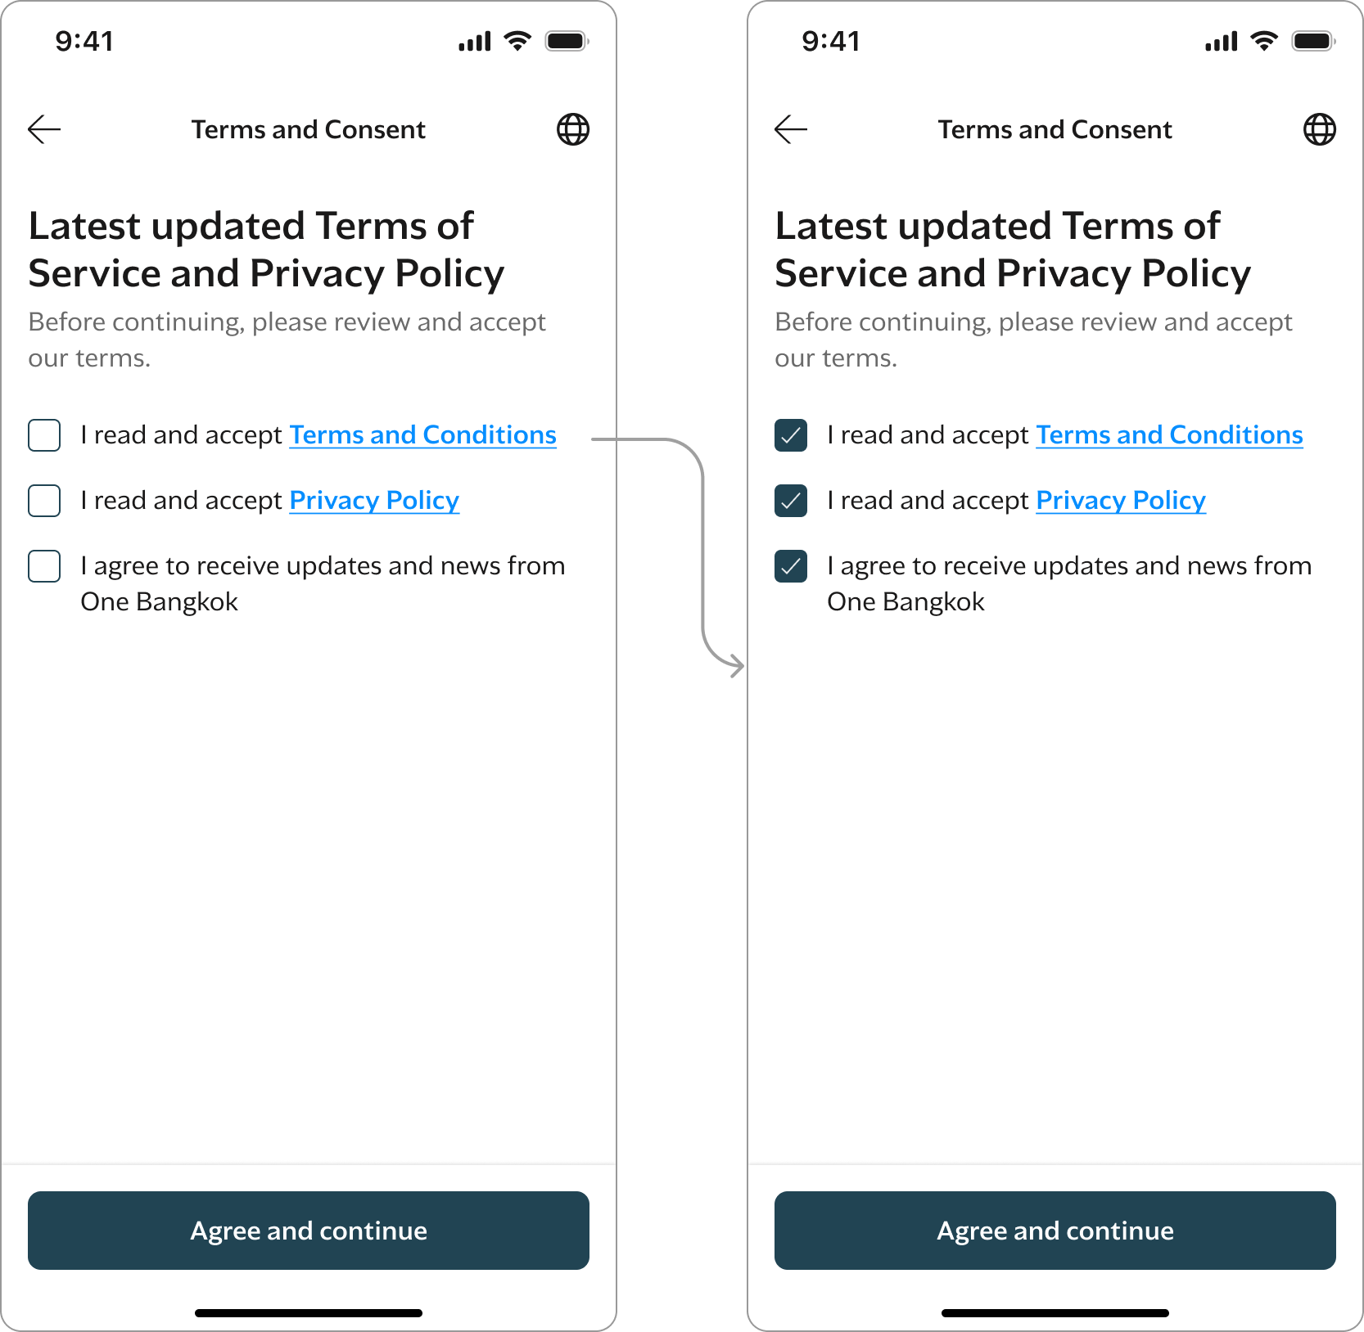

Step 4 – Complete Account Setup
User must:
- Choose Email or Phone
- Complete OTP verification
- Set password
- Select persona (Thai / Non-Thai)

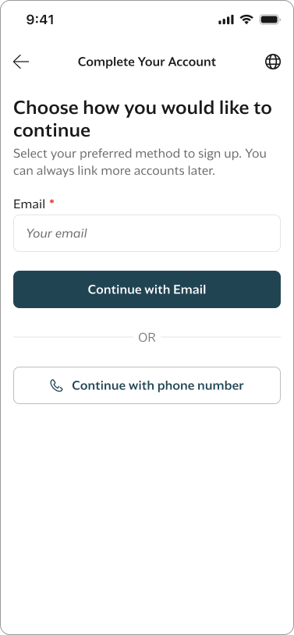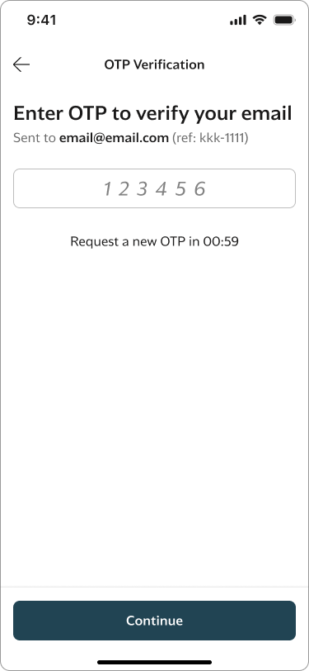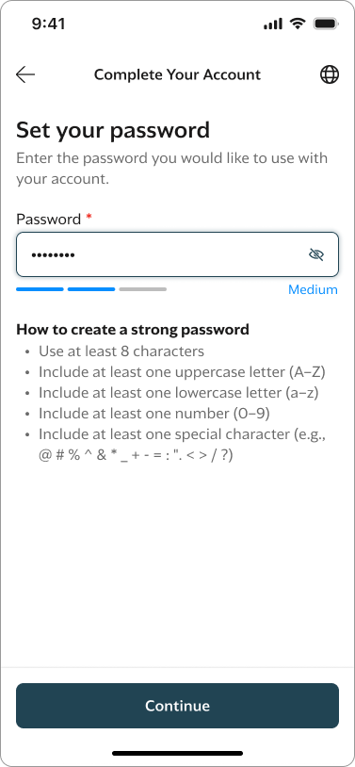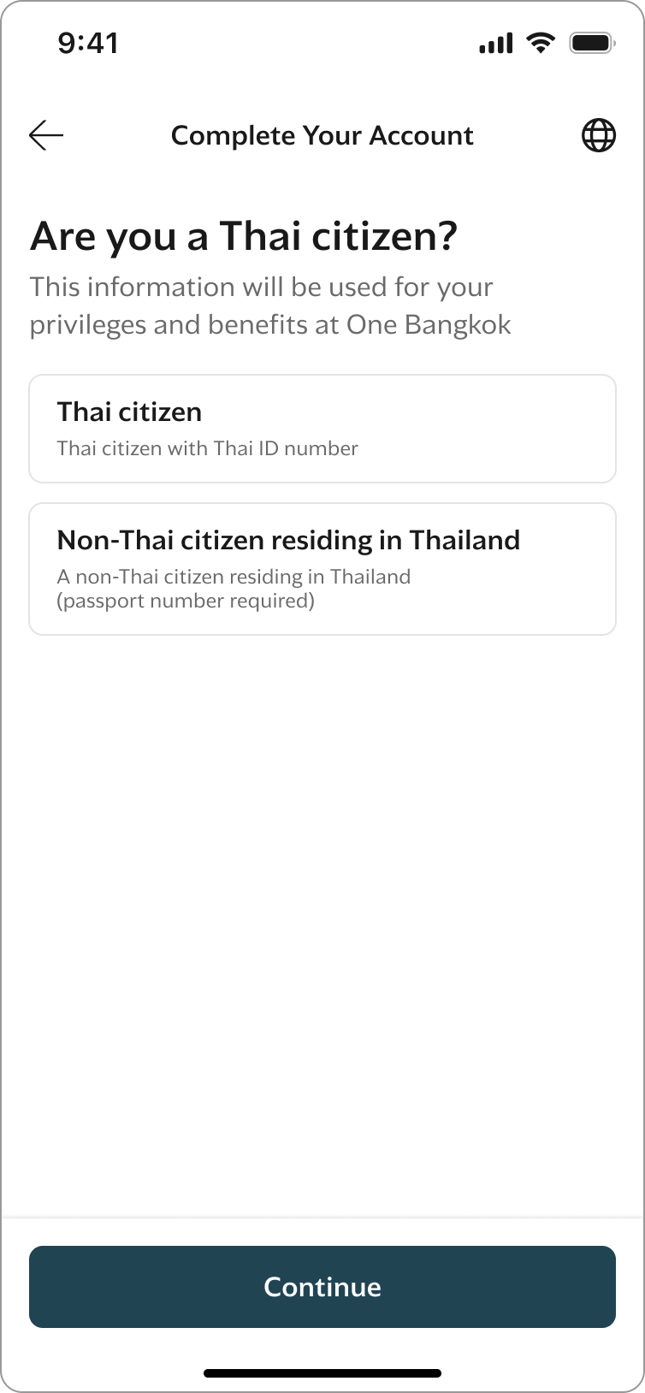

Step 5 – Account Creation
After successful completion:
- Account is created
- Invitation Code is deactivated
- Tier is assigned automatically
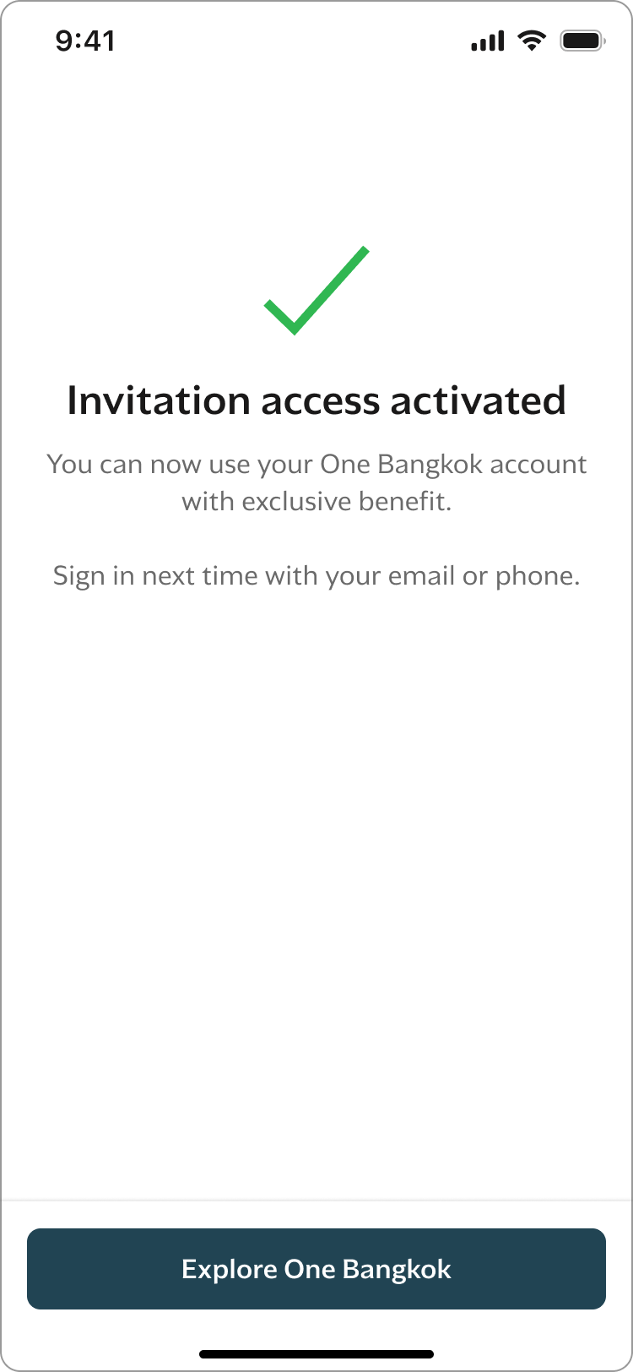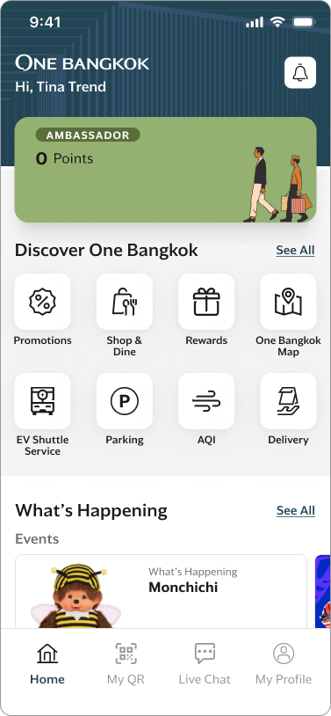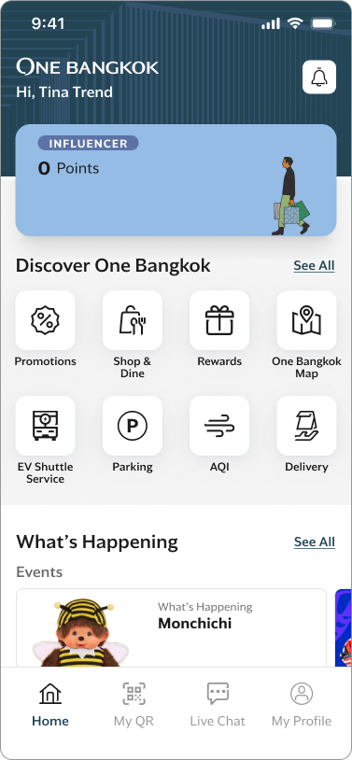
Tier assigned automatically (Influencer or Ambassador)

Business Rules – Invitation Code
Rule | Description
Code Length | 10 characters
Character Set | A–Z, 0–9
Expiry | Last day of calendar year
Usage | Single-use
Tier | Influencer / Ambassador
Deactivation | After successful account creation only  *If a user exits before completion, the code remains active.

Profile Restrictions for Invited Users
For users registered via Invitation Code:
Editable:
- Date of Birth
- Address
- Gender
- ID Card / Passport (if not provided)
Not Editable:
- First Name
- Last Name

Error Handling – Invitation Code
Scenario | Display
Empty | 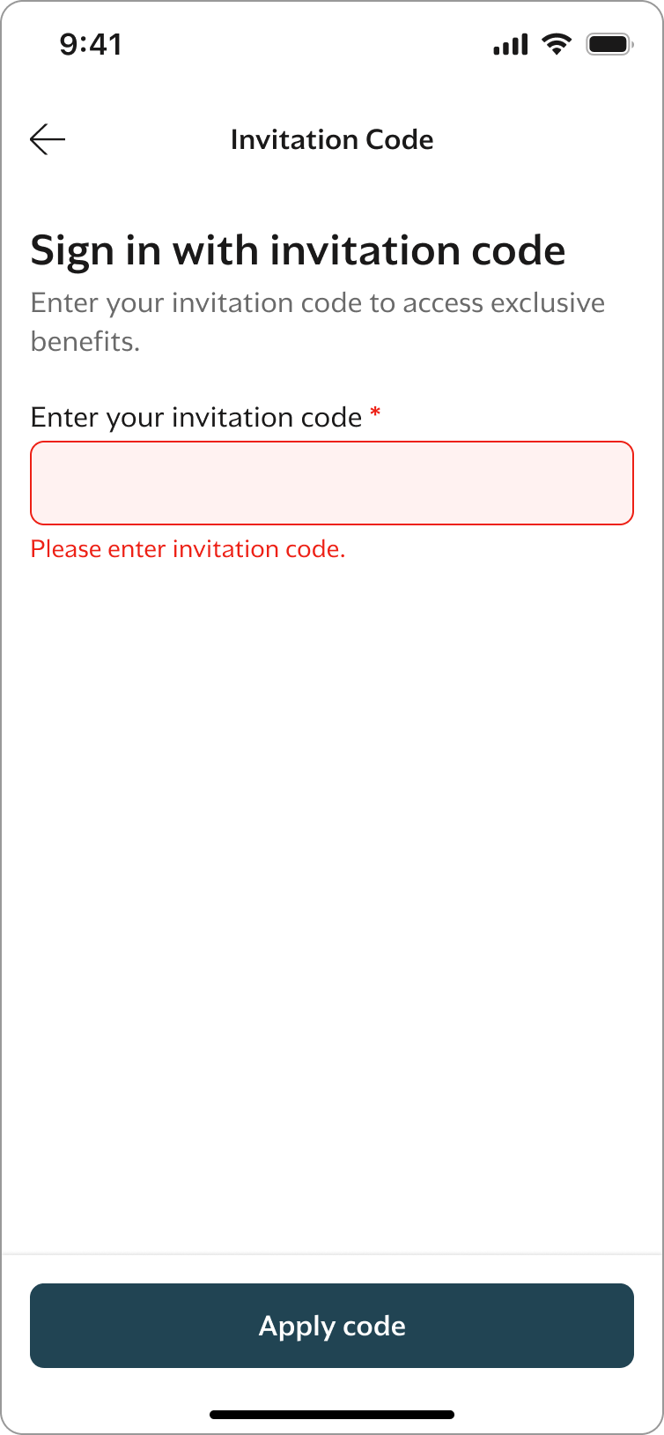
Invalid format or not found | 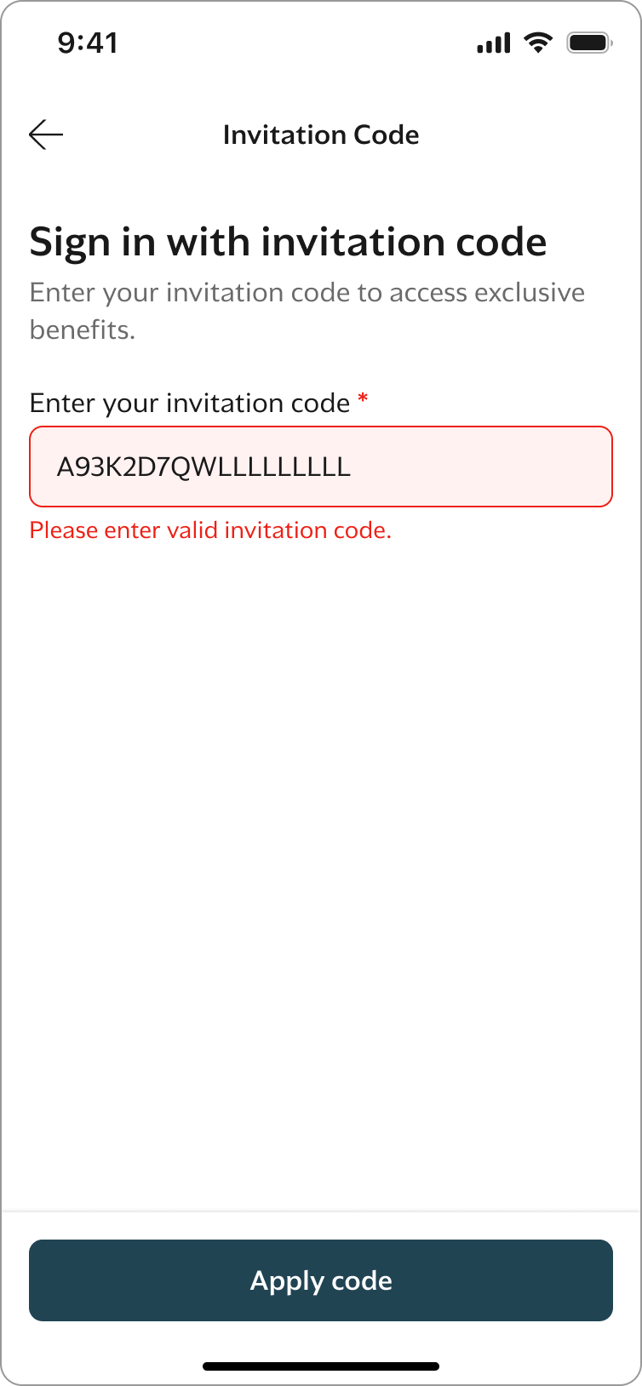
Code already used | 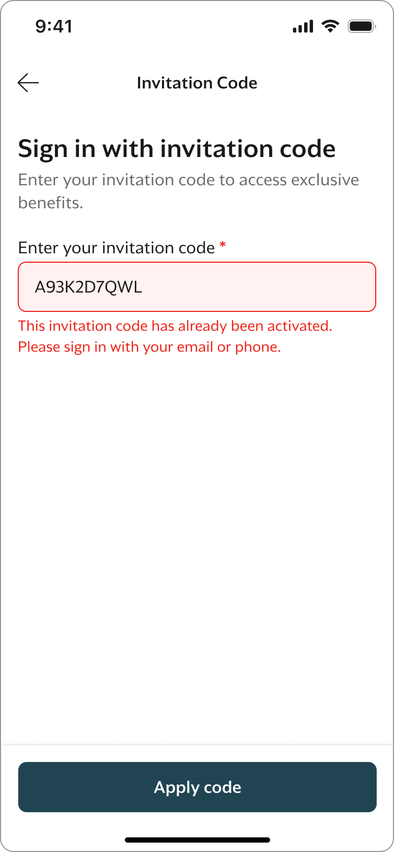
Code expired | 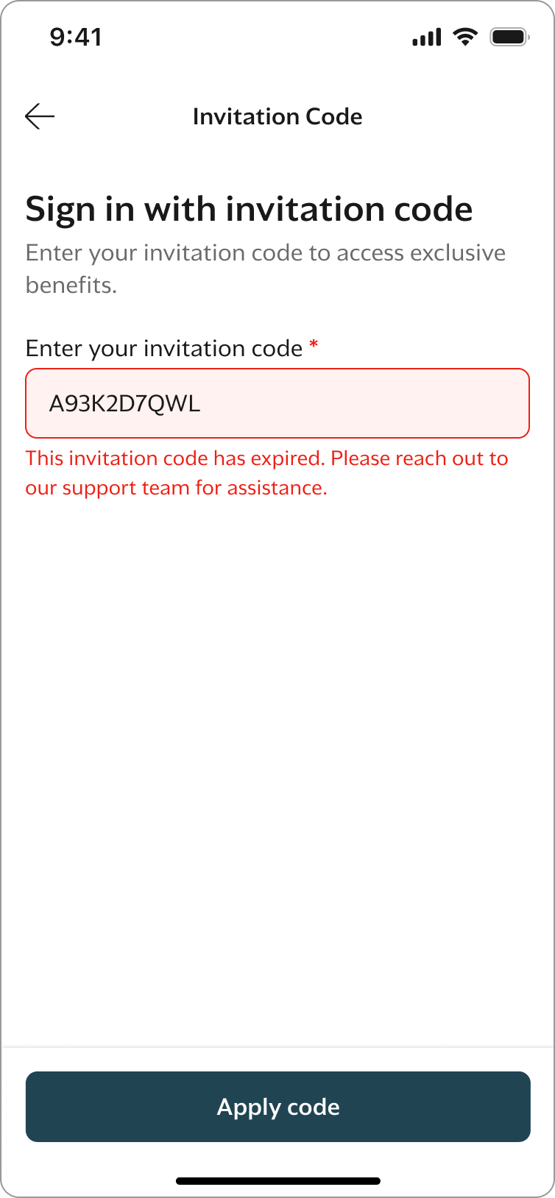

Upgrade Membership

Purpose
Upgrade Membership allows existing users to upgrade their retail tier using a special code provided by Retail BU. This feature replaces the previous webview-based process.

User Journey – Upgrade Membership

Step 1 – Navigate to My Profile. : User selects “Upgrade Membership”.
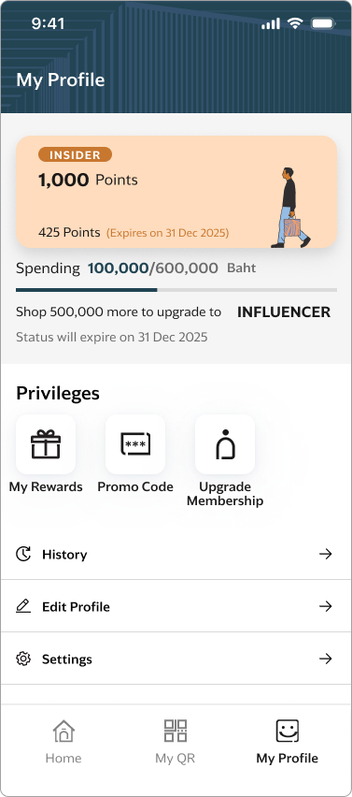

Step 2 – Enter Code: User enters a 10-character code.
System rules:
- Uppercase letters (A–Z), Numbers (0–9)
- Required field
- System checks: Code existence, Not expired, Not used and Associated tier configuration
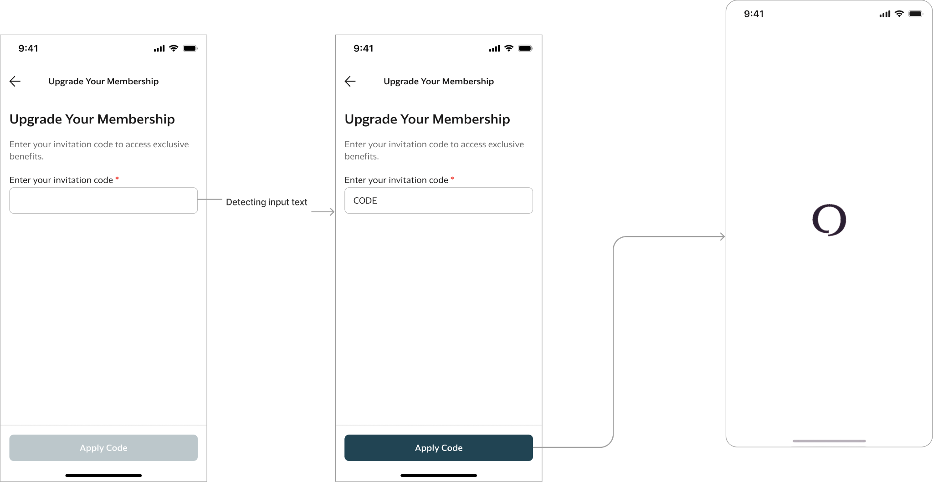

Step 3 – Tier Upgrade: If valid, Tier is updated and Success screen displayed
Remark: If a user applies a new valid code, it overrides the previous tier.
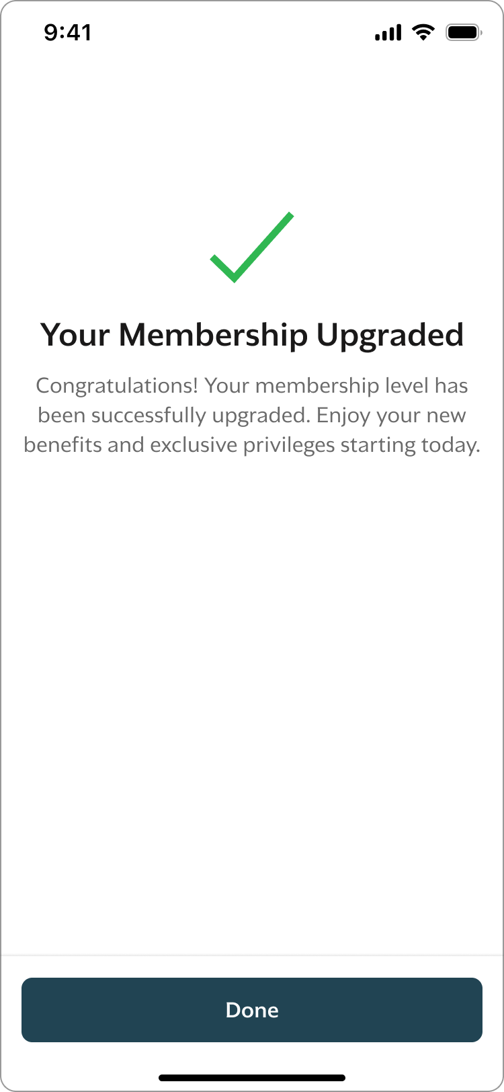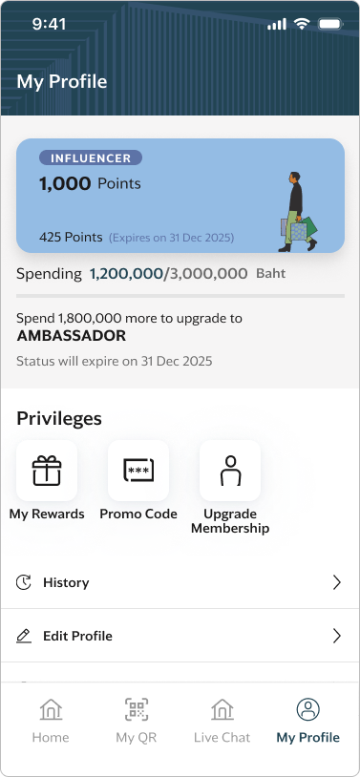
Tier is updated

Business Rules – Upgrade Membership
Rule | Description
Code Length | 10 characters
Character Set | A–Z, 0–9
Expiry | Last day of calendar year
Usage | Single-use
Tier | Influencer / Ambassador

Error Handling – Invitation Code
Scenario | Display
- Invalid code  - Code already used  - Code expired | 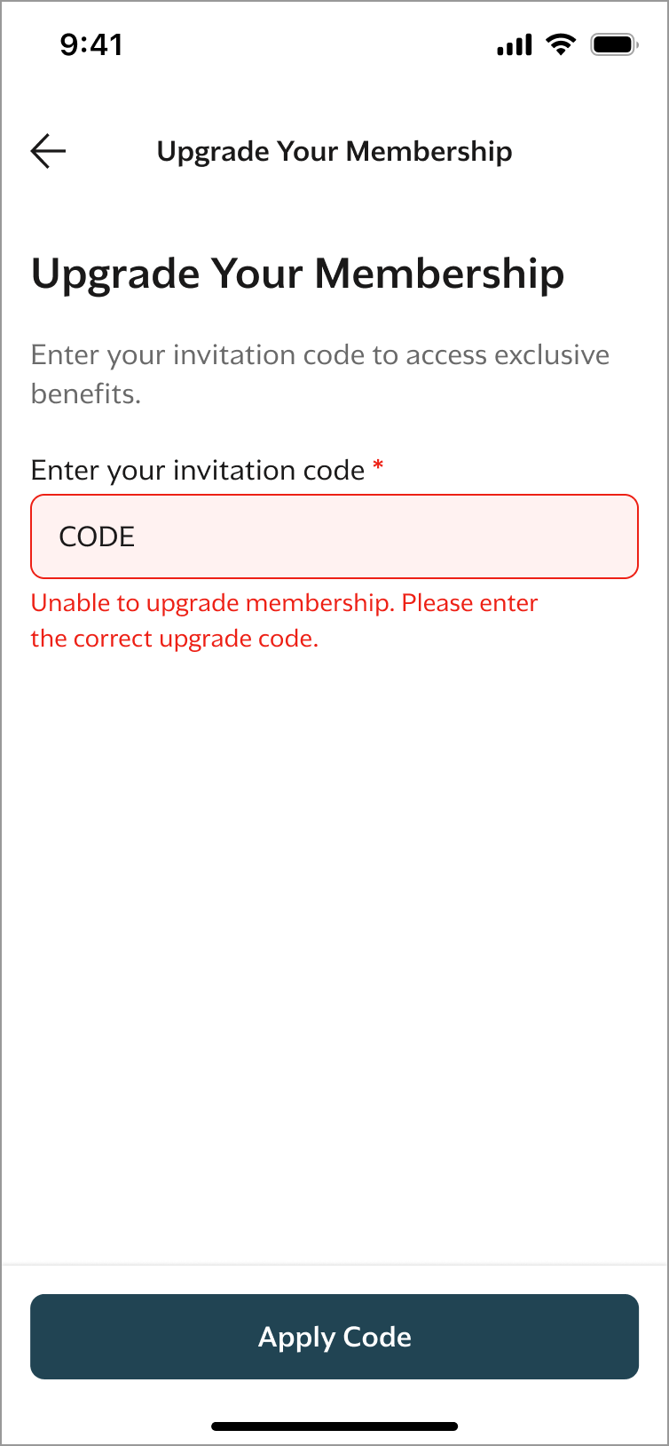

Code Generation (Retail BU Process)
  - Invitation Code Generation
    - Retail BU prepares CSV file:
      - First Name
      - Last Name
      - Tier
    - Upload file via API endpoint
    - System generates:
      - Unique 10-character code
      - Tier mapping
      - Expiry date
    - System returns CSV file with generated codes
Stored Data:
      - VIP First Name
      - VIP Last Name
      - Tier
      - Validity Period
      - Status
  - Upgrade Membership Code Generation
    - Submit request with quantity per tier:
Example: "ambassador": 100, "influencer": 50
    - System generates:
      - Unique 10-character codes
      - Tier mapping
      - Expiry date
    - System returns CSV file

